**Manual to get Windows on your laptop/ Pc**



Session 2022-2026

**Submitted By:**

Ahmar Shahid 2022-CS-206

Taha Shahid 2022-CS-197

**Supervised By:**

Mr. Numan Shafi

Department of Computer Science

**University of Engineering and Technology**

**Lahore Pakistan**

# Copy Data To A Drive Other Than C:\

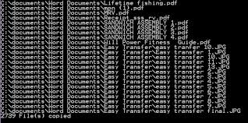

The first step is to copy all of the data that you have in drive C:\ to some other drive. Windows installation causes C:\ drive to be formatted completely. So, this step is extremely important to prevent loss of important data. This should be done in the system in which on you want to install the windows, and not the system in which you will initially be downloading your software. Although, it is possible for both systems to be the same.

# Download ISO file For Windows

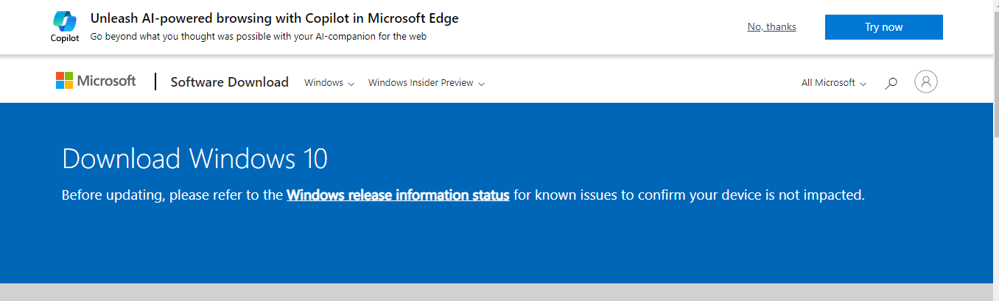

The next step is to download the ISO file for Windows. This file is responsible for the windows installation in your system. However, the file must be converted into a bootable format to be executable. And that is our next step.

Important Note: Select the bit architecture of the system on which you want to install the windows, and do not select the bit architecture of the system in which you are downloading the ISO file. For instance, it is possible that the system in which you are installing windows is a 32-bit system, while the system in which you are downloading the ISO file is 64-bit. In that case, download the 32-bit version.

# Download Rufus File

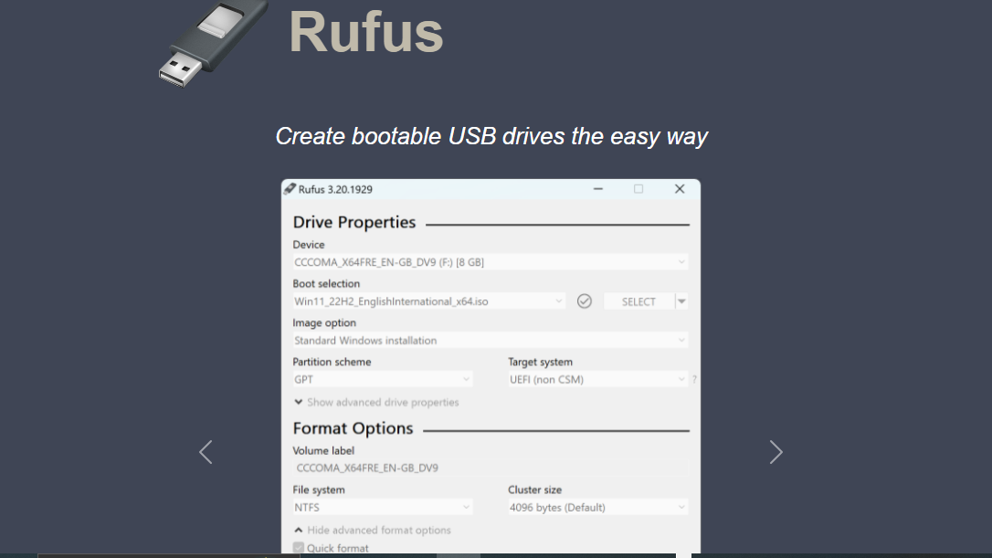

Next step is to download the Rufus software. This will convert our Windows ISO file into a bootable format i.e executable in the absence of an existing OS in the system and executable in the BIOS mode.

# Copy file into USB

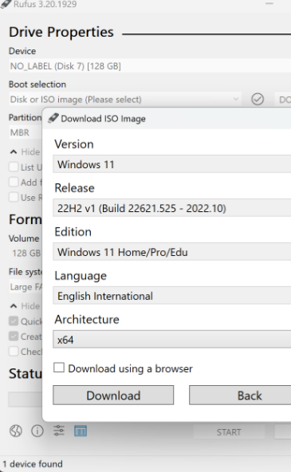

In this step, we use the Rufus software to copy the booted Windows ISO file into a formatted USB, which can be plugged into the systems that require windows installation. Make sure that USB is initially formatted to prevent errors later.

# Starting up the system in BIOS mode

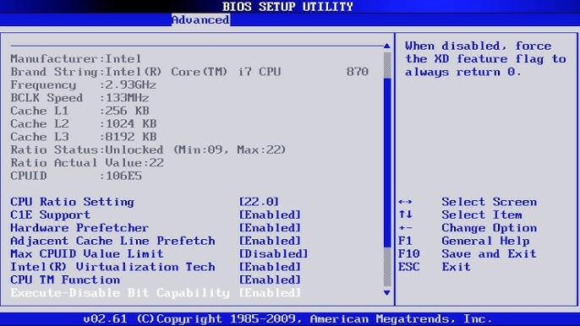

Now let’s start up the system in the BIOS mode. Since there is no existing OS in the system, BIOS is the only mode that you can run your pc on. Note that this system is different from the one in which you downloaded the ISO and Rufus file, unless after downloading, you formatted your pc and deleted windows that you already had.

# Connect your USB

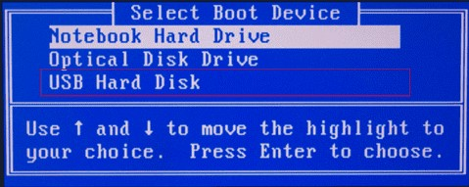

Now, connect the USB in which you copied the booted ISO file and select the USB name in the BIOS menu.

# Select Windows Type

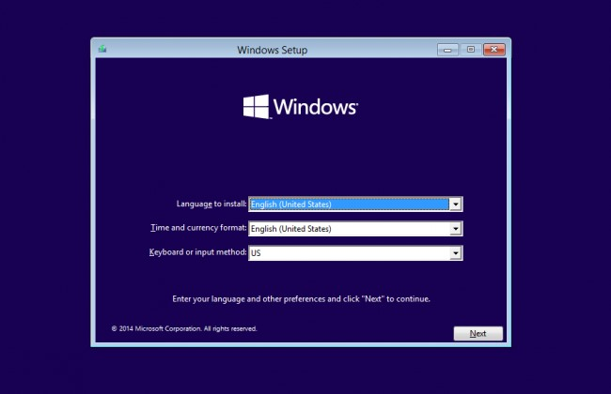

There are going to be some options for you to select from. Select the OS that you want to install on the system. You can notice that the “architecture” column specifies the same architecture as your system i.e the system on which you are installing the windows.

# Select the Drive On which to store the System data

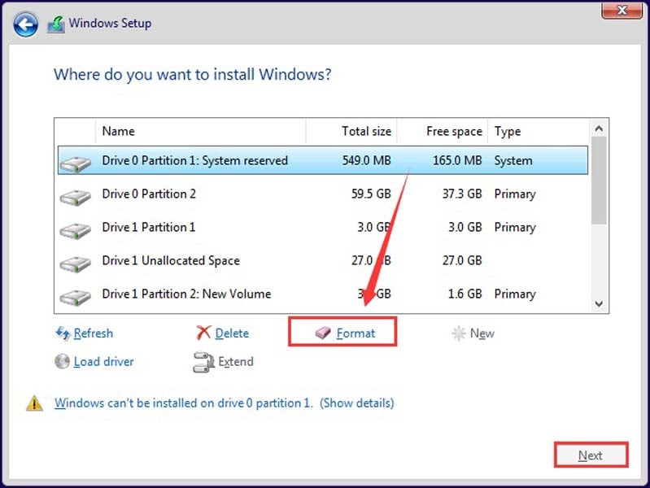

Select the drive on which you are installing all system data. In this case, we are using drive C:\ because in the first step of the manual, we backed up C:\ drive

# Install

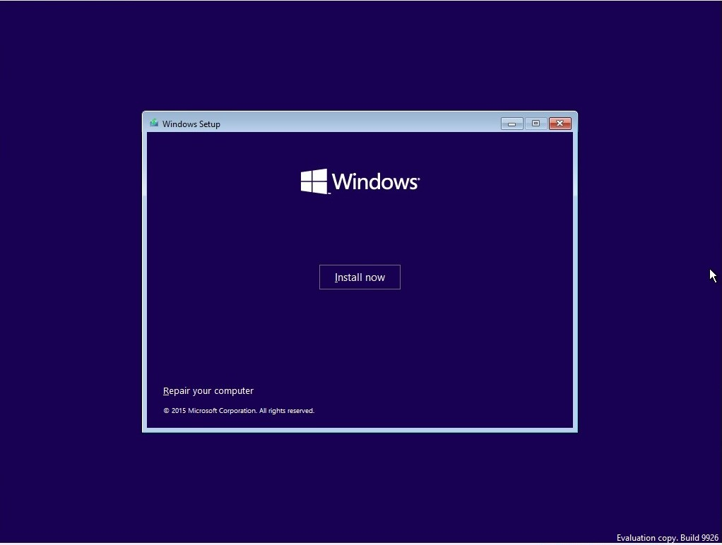

Now wait for installation to complete and that is it.